题目：

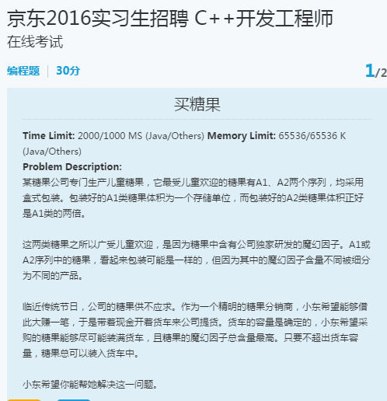

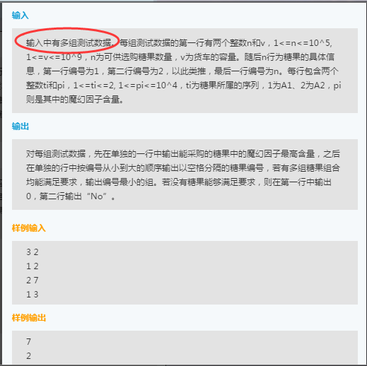

完整代码：

#include<iostream>

#include<string>

#include<vector>

#include<stack>

#include<fstream>

#include<map>

using namespace std;

class Solution {

public:

void dfs(vector<pair<int, pair<int, int>>>& candidates, int target, int &sum, int start){

int size = candidates.size();

for (int i = start; i < size; i++){

if (sum + candidates[i].second.first <= target){

temp.push_back(candidates[i]);

result.push_back(temp);

//凡是容量和小于V的都可加入

sum += candidates[i].second.first;

dfs(candidates, target, sum, i + 1);

temp.pop_back();

sum -= candidates[i].second.first;

}

}

}

vector<vector<pair<int, pair<int, int>>>>combinationSum2(vector<pair<int, pair<int, int>>>&candidates, int target) {

int size = candidates.size();

if (size == 0)return result;

int vtep = 0;//当前的容量

int start = 0;

temp.clear();

result.clear();

dfs(candidates, target, vtep, start);

return result;

}

vector<pair<int, pair<int, int>>>temp;

vector<vector<pair<int, pair<int, int>>>>result;

};

int main(){

int num;//糖果数量

int v;//车子容量

int test;

vector<pair<int,pair<int, int>>>sugle;

vector<vector<pair<int, pair<int, int>>>>re;

Solution s1;

ifstream fin("c:\\users\\dell\\desktop\\sugle_cin.txt");

int v_min, v_now,v_pre;

vector<int>mark;

int count = 0;

while (fin>>num){//每一个测试数据的开始

count = 0;

sugle.clear();

re.clear();

mark.clear();

fin >> v;

int t1, t2;

for (int i = 0; i < num; i++){

fin >> t1;

fin >> t2;

sugle.push_back(make_pair(++count,make_pair(t1, t2)));

}

re = s1.combinationSum2(sugle, v);

v_min = 0;

for (int i = 0; i < re.size(); i++){

v_now = 0;

for (int j = 0; j < re[i].size(); j++){

v_now += re[i][j].second.second;

}

if (v_min <= v_now){

if (v_min < v_now){

v_min = v_now;

mark.clear();

mark.push_back(i);

}

else{

mark.push_back(i);

}

}

}

cout << v_min << endl;

for (int i = 0; i < mark.size(); i++){

for (int j = 0; j < re[mark[i]].size(); j++)

cout << re[mark[i]][j].first << " ";

cout << endl;

}

}

return 0;

}

唯品会笔试题目：

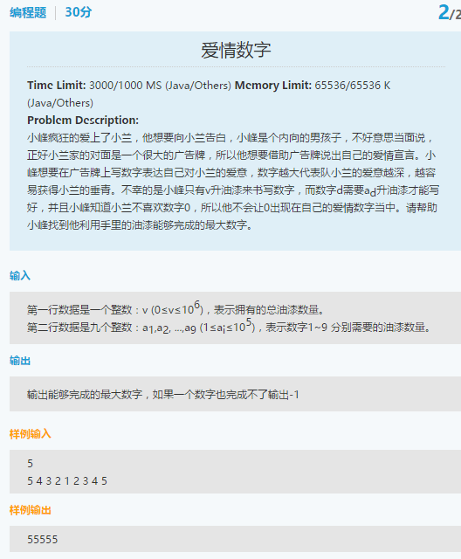

道理同上;